RIEKO O BRIAN:
BCSC01/0047/2018:
COMPILER CONSTRUCTION AND DESIGN:

ASSINGMENT
Design a compiler for a new programming language indicating how each phase of compiler construction is implemented.
Required
1. Full design document (30 Marks)
2. Code for each section (20 Marks)

I choose to create my compiler in python. It’s the language I believe I can at least do something in.
For my case I had encountered many challenges, the reason being the previous classes why not well covered. The resources offered were not enough.
In this development I had tried to develop something.
I choose an easy compiler that I could construct but could also give an idea of what is expected.
Designing a compiler there are steps to be followed for one to be successful and with a fully operational compiler.

STEP 1:
I’ll start by defining my own language. Let’s call it TOY, here’s a simple example of a TOY program:
I using PLY as lexer and parser, and LLVMlite as low level intermediate language to do code generation with optimizations
LLVMlite is a hard library to use. In the previous class we were not taught on this library and it was never in our assembly or machine learning class.

I will start by defining my language Name: NUTS
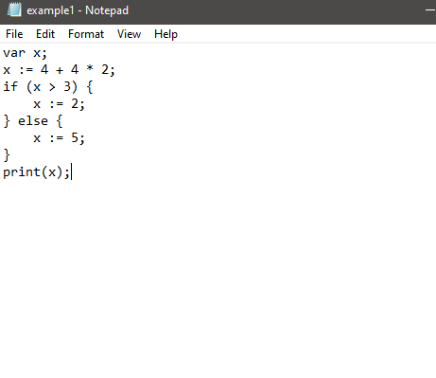

This example looked so easy but to implement it as a programming language really became too hard to.
So I decided to do something easy going like the following;
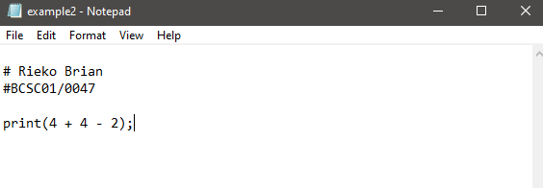
The values can be expected to change going on.
Through this example it’s impossible to show everything a language can do;
We need EBNF to define all possible grammar structures of a language. Which is available online

EBNF
Creating EBNF for NUTS to describe the minimal functionality only sum operation.
10 + 52;
The EBNF can be;
expression = number, "+", number, ";";
number = digit+;
digit = [0-9];

But since the example above is somehow simpler we need to add some functionalities to our;
The first functionality you can add many numbers as possible but we need to create some more for subtraction too:
For our new programming language this will be the example;
52+ 10 - 2;
Its EBNF is;
expression = number, { ("+"|"-"), number }, ";";
number = digit+;
digit = [0-9];

We need to add printing to our programming language.
print(10 + 52 - 2);
The EBNF will be;
program = "print", "(", expression, ")", ";";
expression = number, { ("+"|"-"), number } ;
number = digit+
digit = [0-9];

Since we have defined our grammar we need to translate it into a code.
After it to a code, we need to understand the program and after all compile it.

Compiler
A compiler is a program that turns a programming language into machine language or other languages.
I compiled this programming language into LLVM IR then into machine language.
Using LLVM, it was possible to optimize my compilation without learning compiling optimization, and LLVM had a really good library to work with compilers.
The compiler can be divided 3 components.
Lexer
Parser
Code Generator
For the Lexer and Parser I used RPLY, which is really similar to PLY: a Python library with lexical and parsing tools.
And for the Code Generator, I used LLVMlite, a Python library for binding LLVM components.
Lexer
The first component of the compiler is the lexer
It takes program as input and divides it into tokens.
From the minimal structures of the EBNF to define our tokens. With the following input:
print(4 + 4 - 2);
The Lexer would divide this string into this list of tokens:

Token('PRINT', 'print')
Token('OPEN_PAREN', '(')
Token('NUMBER', '4')
Token('SUM', '+')
Token('NUMBER', '4')
Token('SUB', '-')
Token('NUMBER', '2')
Token('CLOSE_PAREN', ')')
Token('SEMI_COLON', ';')

So, the first step to the start creating the compiler.
:- First,I created a file named lexer.py. I defined the tokens on this file.
I only use LexerGenerator class from RPLY to create the Lexer.

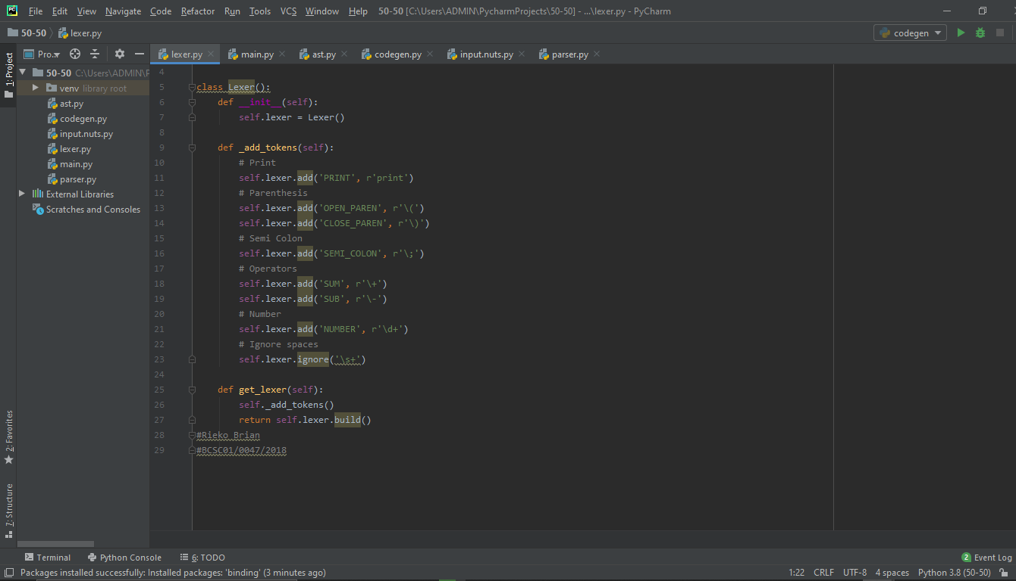

:-Second create main file named main.py. I combined all three compiler components on this file.
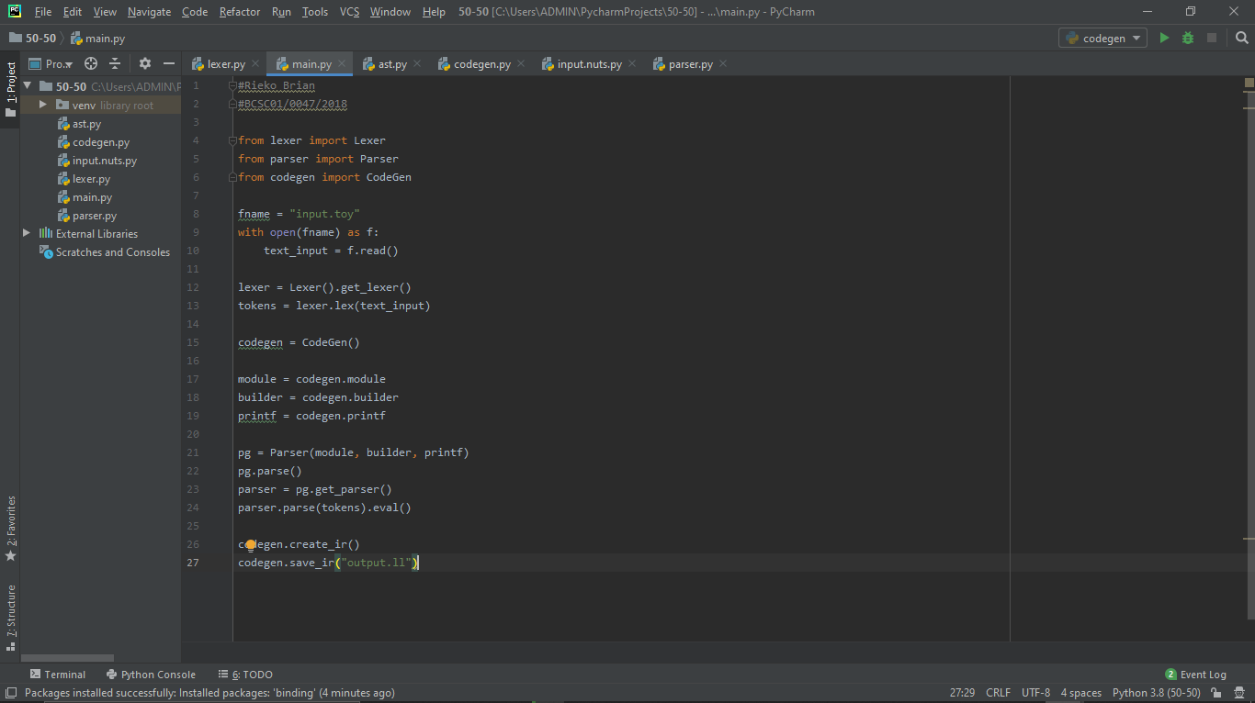
Parser
The second component in the compiler is the Parser. Its role is to do a syntax check of the program.
It takes the list of tokens as input and create an AST as output.
To implement the parser, I used the structure I created with the EBNF as model. RPLY’s parser uses a format really similar to the EBNF to create its parser, so it is really straightforward.
-First, I created a new file named ast.py. It will contain all classes that are going to be called on the parser and create the AST
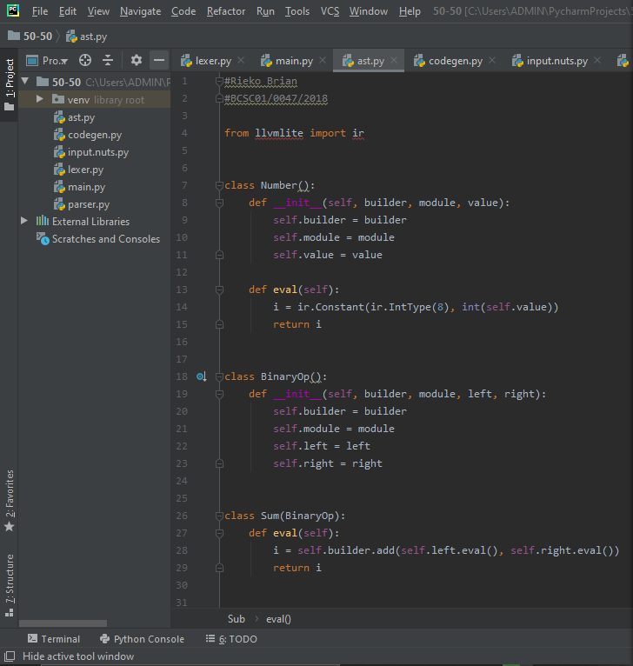

-Second, I created the parser. For that, I used the ParserGenerator from RPLY. Create a file name parser.py
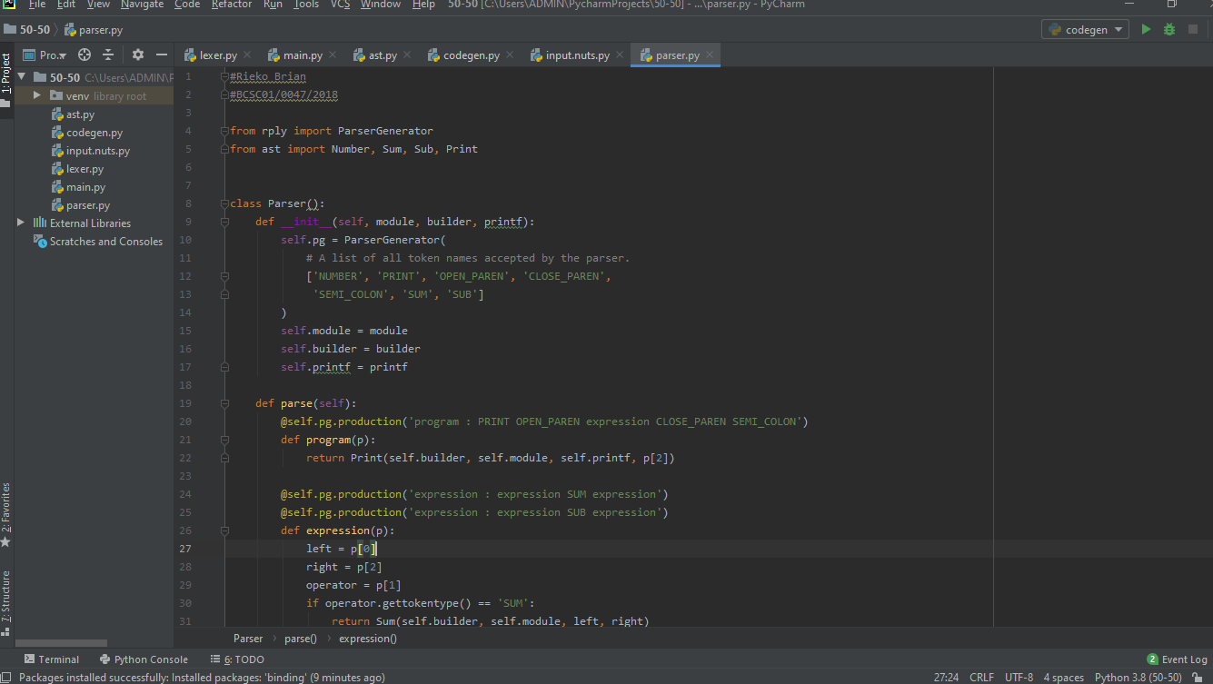

Update our file main.py to combine Parser with Lexer.

Running input.nuts.py, one will see the output being the result of print(10 + 52 — 2), which is equal to printing 62.
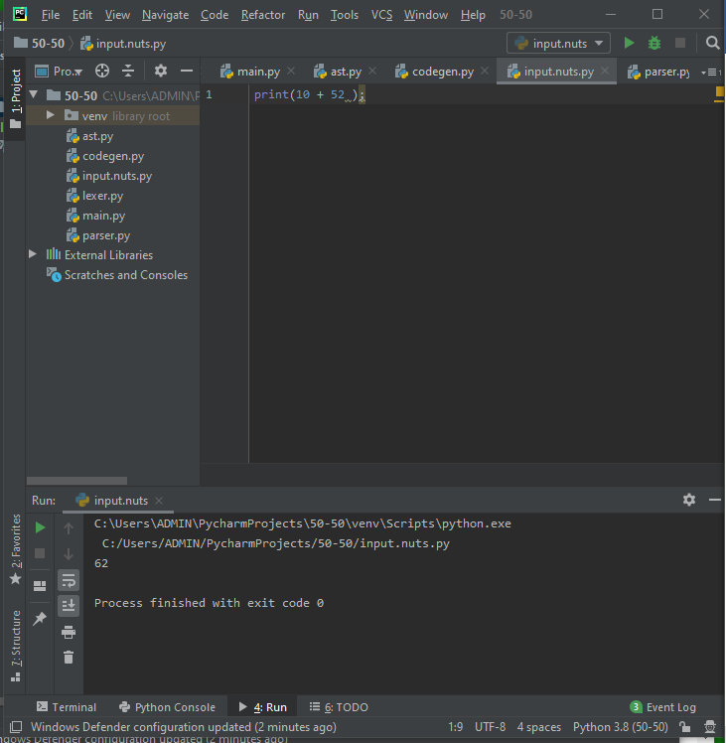
With these two components, we have a functional compiler that interprets NUTS language with Python. However, it still doesn’t create a machine language code and is not well optimized. To do this,ode generation with LLVM.

Code Generator
The role of code generator is to transform the AST created from the parser into machine language. It’s going to transform the AST into LLVM IR
LLVMlite doesn’t have an implementation to a print function, so one has to define your own.
Create a file named codegen.py that will contain the class CodeGen.
This class is responsible to configure LLVM and create and save the IR code. We also declare the Print function on it.
-I created a file named codegen.py that will contain the class CodeGen. This class is responsible to configure LLVM and create and save the IR code. We also declare the Print function on it.
Code will be uploaded in (.txt)
- One has to update the main.py file to call CodeGen methods:
Code will be uploaded in (.txt)
- I removed the input program from this file and created a new file called input.nuts to simulate an external program.
- Another change that I made is passing module, builder and printf objects to the Parser. This was made so we could pass this objects to the AST, where the LLVM AST is created. So, we change parser.py to receive these objects and pass them to the AST
- The ast.py has to be change to receive these objects and create the LLVM AST using LLVMlite methods

- With all these changes, compiler is ready to transform a NUTS program into an LLVM IR file output.ll. To compile this .ll file into an executable ONES has to use LLC to create an object file output.o, and finally, GCC to create the final executable file.

